Suvarnabhumi Airport Lounge (Please Go to 3rd Floor)
Update: 07 Nov 2015
 | Airline / Credit Card | Lounge | Location | Gate
1 | ASIANA Airline | Thai Royal Silk Lounge | WEST/EAST | C,D,E
2 | ANNA Airline (ANA) | Thai Royal Silk Lounge | WEST/EAST | C,D,E
3 | AIR Canada | Thai Royal Silk Lounge | WEST/EAST | C,D,E
4 | Air France | Air France Lounge | WEST/EAST | F
5 | AIR China | Thai Royal Silk Lounge | WEST/EAST | C,D,E
6 | Austrian Airline | Thai Royal Silk Lounge | WEST/EAST | C,D,E
7 | Aeon Credit Platinum | Thai Royal Silk Lounge | WEST/EAST | C,D,E
8 | British Airways | Qantas & British First /Business Class Lounge | WEST | G
9 | Bangkok Airways | Blue Ribbon Club | EAST | A
10 | China Airlines | China Airline Dynasty Lounge | WEST | D
11 | Cathay Pacific | Cathay Pacific First & Business Class Lounge | WEST | D,G
12 | City Bank Platinum | CIP-Louis Tavern | WEST/EAST | A,F,G
13 | Chang Massage | Chang Massage | WEST/EAST | A,G
14 | Diners club (Affiliated Platinum Credit Card holder) | CIP | WEST/EAST | A,F,G
15 | Emirates | Emirates Lounge | WEST | D
16 | EVA | EVA | WEST | F
17 | Gulf Air | Gulf Air | WEST | F
18 | Japan Airline | JAL (SAKURA) Lounge | WEST | D
19 | Korean Airline | Miracle CIP, Air France | WEST | F
20 | Kbank Wisdom | Wisdom | EAST | A
21 | King Power Lounge | King power Lounge 4Floor | EAST | A
22 | Louis’ Tavern CIP / PRIORITY (PP) | CIP | WEST/EAST | A,G,F
23 | Louis’ Tavern CIP Business Class Lounge | CIP | WEST/EAST | A,G,F
24 | Louis’s Tavern CIP Lounge | CIP | WEST/EAST | A,G,F
25 | Qatar Airways | Qatar Airways | WEST | F
26 | Oman Air | Oman Air Lounge | WEST | E
27 | Qantas Airways | Qantas & British First /Business Class Lounge | WEST | G
28 | Singapore Airline | SilverKris Lounges | EAST | A
29 | Star Alliance Operating flight (TG) | Thai Royal Silk Lounge | WEST/EAST | A,D,E
30 | Star Alliance Operating First Class flight (TG) | Thai Royal First Lounge/ Business Lounge | EAST | D
31 | Turkish Airline | Thai Royal Silk Lounge | WEST/EAST | C,D,E
32 | THAI Airways | Royal First & Silk, Orchid | WEST/EAST | A,D,E
33 | THAI Airways | Thai Royal Orchid Spa | WEST/EAST | C,E
34 | THAI Airways | Thai Special Care Passengers | WEST/EAST | D,D
35 | Transaero Airlines | Tramsaero Airlines Business Lounge | WEST | G
* Kbank ,Aeon, Citybank PLATINUM Credit Card holder departing same day on any Star Alliance operating flight (TG) Thai Airways Royal Silk Lounge
* CIP Lounge Shower (Gate: G) Price 350B / Hotel + Shower 4Hrs 3,300B

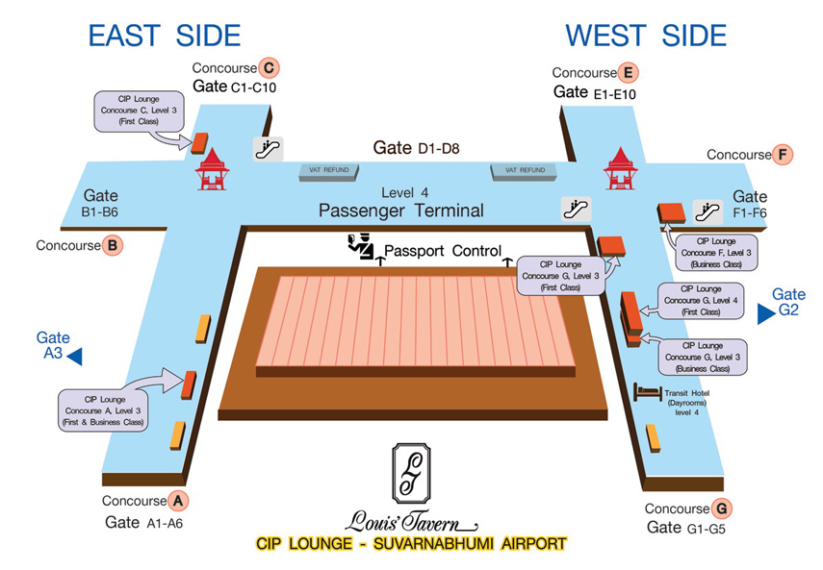

Thai Airways with Star Alliance operating flight allowed

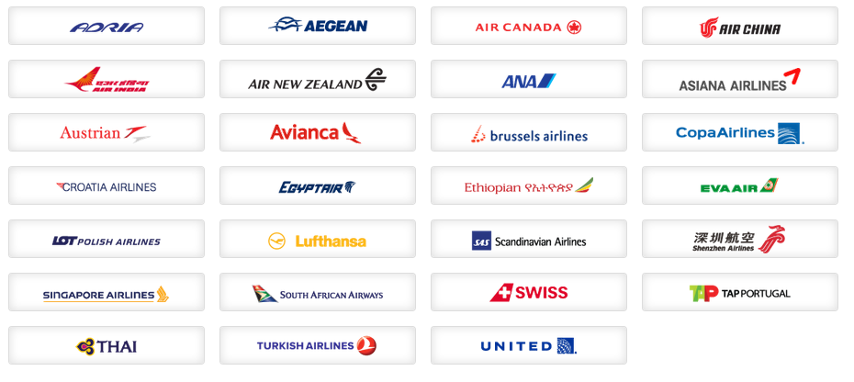

Sky Team operating flight allowed

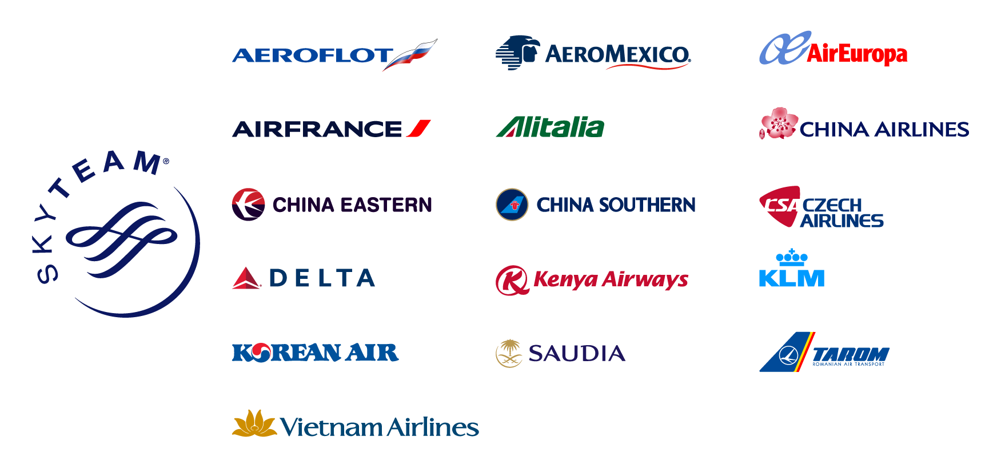

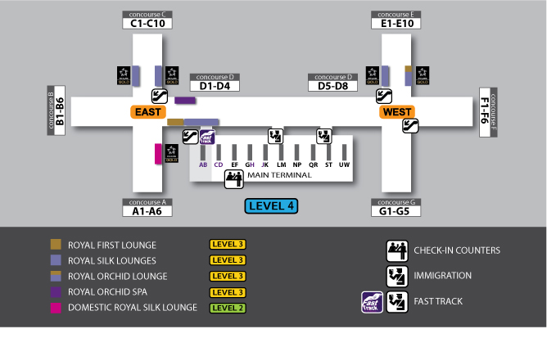

Royal First Lounge at Concourse D, Level 3

Lounge Access :
• Royal First Class passengers departing the same day on TG operating flight
- One guest departing same day on any Star Alliance operating flight allowed
• First Class passengers departing same day on any Star Alliance operating flight
- One guest departing same day on any Star Alliance operating flight allowed
• Royal Orchid Plus Platinum card holder departing same day on TG operating international flights
- One guest departing same day on TG operating flight allowed

Royal Silk Lounge at Concourse D, Level 3

Lounge Access:
• Royal Silk Class passengers departing same day on TG operating international flight
- No guest allowed
• Business Class passengers departing same day on any Star Alliance operating flight
- No guest allowed
• Royal Orchid Plus Platinum card holder departing same day on TG operating international flight
- One guest departing same day on any Star Alliance operating flight allowed
Royal Silk Lounge at Concourse C - East, Level 3

Lounge Access:
• Royal Silk Class passengers departing same day on TG operating international flight
- No guest allowed
• Business Class passengers departing same day on any Star Alliance operating flight
- No guest allowed
• Star Alliance Gold card holders departing same day on any Star Alliance operating flight
- One guest departing same day on any Star Alliance operating flight allowed

Royal Silk Lounge at Concourse C - West,

Lounge Access:
• Royal Silk Class passengers departing same day on TG operating international flight
- No guest allowed
• Business Class passengers departing same day on any Star Alliance operating flight
- No guest allowed
• Star Alliance Gold card holders departing same day on any Star Alliance operating flight
- One guest departing same day on any Star Alliance operating flight allowed

Royal Silk Lounge at Concourse E - East, Level 3

Lounge Access:
• Royal Silk Class passengers departing same day on TG operating international flight
- No guest allowed
• Business Class passengers departing same day on any Star Alliance operating flight
- No guest allowed
• Royal Orchid Plus Gold and Star Alliance Gold card holder departing same day on any Star Alliance operating flight
- One guest departing same day on any Star Alliance operating flight allowed

